1. **Project Title**

Exploring the impact of Competition and Cooperation on Performance and Engagement in VR Exergaming

1. **Project Description**

This project explores how different VR cycling scenarios, each with distinct cooperative and competitive dynamics, impact user performance, engagement, and fitness outcomes. Past research has shown that competition and cooperation in VR exergaming has elicited greater intrinsic motivation and incentivised participants to travel further virtually and expend more calories compared to cycling with a ghost or by themselves (Shaw et al., 2016). A paper published in 2020 also showed that in a longitudinal study over 4 weeks participants saw on average a 16% increase in performance through using multi-ghost methods for high intensity interval training (HIIT) (Michael et al., 2020). By creating a VR exergame that combines competitive and cooperative dynamics with the physiological technique of interactive feedforward through the use of AI that (a) adjusts behaviour before participant failure, (b) predicts future effort based on baseline test, (c) creates a proactive challenge irrelevant of the participants physical ability, this project aims to deliver an engaging and performance-oriented exergaming experience that is intuitive and useable by a range of fitness levels, from complete beginners to high performance athletes.

The core concept is to design multiple distinct scenarios that differ in social interaction and style but ultimately provide the same workout throughout them all. Each scenario will test how the factors of cooperation and competition impact performance and motivation. The three scenarios are:

* **Baseline Scenario (1km Distance)** – A neutral cycling scenario with no social elements, serving as a control condition for performance comparisons.
* **Cooperative Scenario (1km Distance)** – A team pursuit where the player drafts with AI teammates, working together to optimise speed and pacing.
* **Competitive Scenario (1km Distance)** – A scratch race where the player competes against AI opponents, encouraging rivalry and strategic exertion.

These scenarios will feature identical visuals and environmental conditions but introduce variations in social interaction. To evaluate the effectiveness of the game, the project will involve a mixed-methods study. Participants will complete each scenario and at a minimum, data on speed, cadence, heartrate, and time will be recorded. Power output will also be recorded provided wattage data is available with hardware used. Additionally, qualitative data will be collected through user feedback surveys to understand the scenarios impact on motivation, enjoyment, and overall experience. The study will also assess how different gameplay elements influence users’ willingness to maintain a fitness routine. Participants will also be asked to complete a personality test for later reference to evaluate if there is any correlation between particular personality types favouring or performing greater in a particular workout dynamic.

By integrating real-time performance tracking, social interaction mechanics, and post-race analytics, this project will assess the impact of these different gameplay structures on user experience and engagement with VR-based fitness. The project also emphasises scalability, with the potential to integrate additional scenarios in the future.

By combining immersive VR environments with carefully designed social interaction mechanics, this project aims to contribute to the fields of VR gaming, technology in fitness, and exergaming research. It seeks to demonstrate how cooperative and competitive dynamics optimise user performance and provide a solution that ensures sustained engagement in fitness activities. Beyond academic implications, the project has the potential to provide a strong model for innovative, accessible, and enjoyable exergaming experiences.

1. **Aims and Objectives**
   1. **Aim**

To develop a VR cycling game with varied social interaction designs that investigate how cooperative and competitive gameplay influences user performance, engagement, and fitness outcomes. This project aims to address the lack of accessible and engaging VR cycling platforms that cater for users with different motivational triggers and interests.

* 1. **Objectives**
     1. **Design and Develop Scenarios**
* Create at least three distinct VR cycling scenarios within the same velodrome environment.
* **Baseline Scenario:** A plain cycling experience with no additional narrative.
* **Cooperative Scenario:** A team pursuit where the player collaborates with AI teammates.
* **Competitive Scenario:** A scratch race where the player competes against AI opponents.
* **Risk:** Development taking longer than expected, leading to delays in testing and evaluation.
* **Mitigation:** develop a minimum viable product for each scenario first, ensuring basic functionality before refinement.
  + 1. **Incorporate Social Interaction and Gamification Elements**
* Implement real-time performance tracking, live progress updates, and leaderboard rankings for the competitive scenario through Unity UI.
* Integrate drafting mechanics in the cooperative mode to encourage teamwork and efficiency.
* Include post-race performance analytics to help participants compare their effort across different scenarios.
* **Risk:** if AI is too easy, players won’t feel challenged, and if too difficult, they may lose motivation.
* **Mitigation:** allow for dynamic difficulty adjustments using real-time performance.
  + 1. **Evaluate Performance and Engagement Across Scenarios**
* Test user performance metrics such as speed, cadence, power, heart rate and time to completion across scenarios.
* Collect qualitative feedback on user engagement, scenario preferences and perceived motivation through feedback forms.
* **Risk:** Bugs in logging system might lead to missing or incorrect performance data.
* **Mitigation:** implement automated data backups and verification checks to ensure data integrity.
  + 1. **Ensure Accessibility and Usability**
* Design an intuitive interface and implement adjustable AI difficulty as well as recommended difficulty calculated from user’s baseline test to make the game accessible to users of all fitness levels.
* **Risk:** if menus and overlays are too complex, users may struggle to interact with the VR Cycling System.
* **Mitigation:** follow UI/UX best practices such as minimal clutter, intuitive design, and tooltips for guidance.

1. **Feasibility**
   1. **Ethical Approval**

No significant ethical concerns are anticipated for this project as it involves voluntary participation in a VR cycling game. Participants’ data will be anonymised, and informed consent will be obtained before their involvement.

* 1. **Legal Concerns**

This project will rely on third-party tools like Unity for VR development and potentially commercially available smart trainers for cycling hardware depending on the extent in which hardware compatibility is explored. Unity has free licensing tiers for academic purposes, ensuring compliance. Any sound effects, textures, or models used will be sourced from open-license repositories or created in-house.

* 1. **Special Resources**

The project requires the following resources:

VR Hardware: A headset such as the Oculus Quest 2 and cycling hardware like a smart trainer or exercise bike.

Software: Game development software such as Unity and analytics tools such as Python or R.

1. **Work Plan**
   1. **Spring Week 1: Planning and Background Research**

* Finalise and submit Initial Report.
* Attend VR lab induction to ensure familiarity with equipment and resources available.
* Conduct literature review on VR exergaming, competition vs. cooperation, and performance motivation.
* Identify existing VR cycling studies to better tailor research methodology.
  1. **Spring Week 2: Project Setup and Methodology Finalisation**
* Choose and finalise development methodology.
* Set up Unity development environment and configure VR hardware.
* Select suitable assets.
* Begin Designing VR velodrome map.
* Plan participant recruitment strategy and ethical approval requirements.
  1. **Spring Week 3: Prototype Development (Environment and Input Handling)**
* Develop VR velodrome environment.
* Establish Bluetooth communication with VR lab Watt Bike.
* Implement basic user controls and movement mapping in Unity.
  1. **Spring Week 4: Implementing Baseline Scenario and UI/UX Elements**
* Develop baseline scenario/test.
* Implement real-time performance tracking and a way to store performance after tests.
* Design user interface and heads-up display for performance metrics.
* Conduct preliminary testing of the baseline cycling experience.
  1. **Spring Week 5: Implementing Cooperative Scenario and AI Teammates**
* Develop cooperative scenario:
* AI teammates with drafting mechanics for optimised pacing.
* Implement AI speed adjustments based on player effort.
* Begin implementing data collection system for logging performance data.
* Design post-race performance analytics dashboard.
  1. **Spring Week 6: Implementing Competitive Scenario and AI Opponents**
* Develop competitive Scenario:
* AI opponents with adaptive difficulty mechanics
* Implement leaderboard and real-time race feedback UI relevant for competitive scenario.
* Complete data logging integration for all scenarios.
  1. **Spring Week 7: User Study Advertisement and Preliminary Testing**
* Finalise user study documentation (consent forms, questionnaires, personality tests)
* Begin recruiting participants through university and personal channels.
* Conduct internal pilot testing to refine game balance and useability.
  1. **Spring Week 8: Conducting User Study**
* Run user study with participants completing all scenarios.
  1. **Spring Week 9: Conducting User Study Continued**
* Collect performance and qualitative feedback data.
* Monitor data logging and resolve issues if necessary.
  1. **Spring Week 10: Data Analysis and Evaluation**
* Process and clean quantitative performance data.
* Analyse qualitative feedback for insights on user motivation and preferences.
* Generate graphs and statistical reports comparing scenarios.
  1. **Spring Week 11: Collect Fragments of Documentation for Report**
* Compile collected documentation, e.g. development logs, roadblocks, methods of implementation, conclusions, and self-criticisms.
* Piece together report into desired PATS format.
  1. **Spring Week 12: Finalise and Review Report for Submission**
* Finalise project report with detailed findings.
* Ensure all documentation including references and appendices, is correctly formatted.
* Submit final report to PATS system.

1. **Gantt Chart**

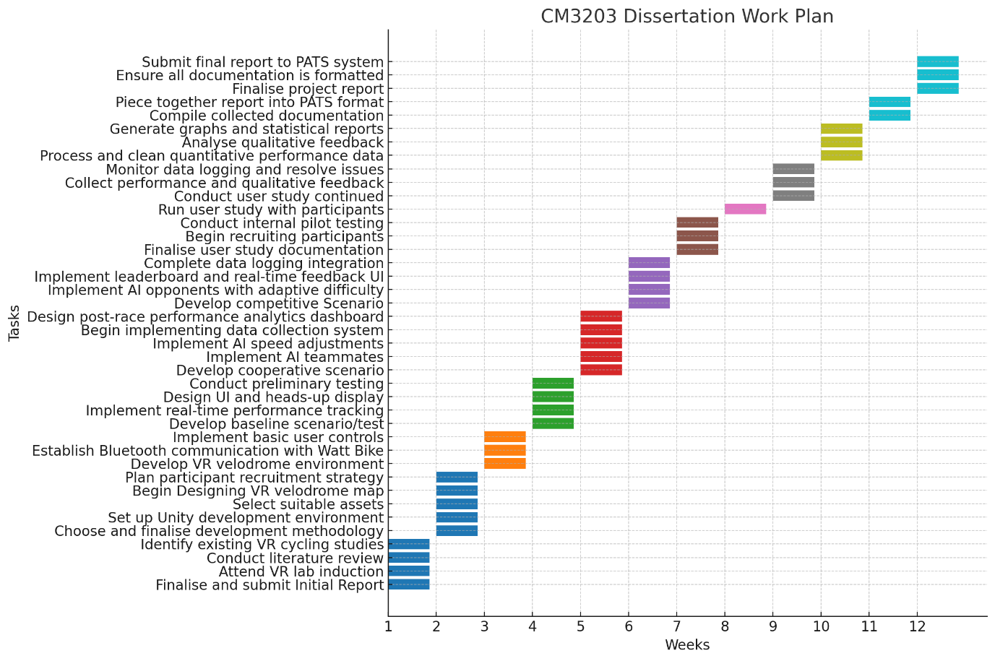

1. **References**

* Shaw, LA, Buckley, J, Corballis, PM, Lutteroth, C, Wünsche, BC. 2016. Competition and cooperation with virtual players in an exergame. *PeerJ Computer Science*, 2: e92.
* Michael, A, Lutteroth, C. 2020. Race yourselves: A longitudinal exploration of self-competition between past, present, and future performances in a VR exergame. *Proceedings of the 2020 CHI Conference on Human Factors in Computing Systems*, pp. 1-17.